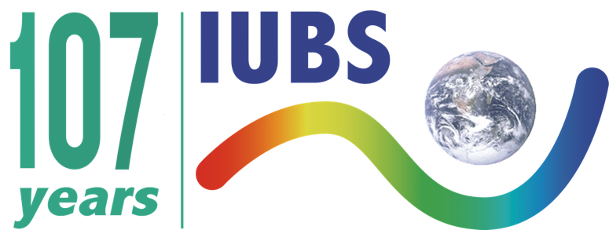

International Conference sponsoring

The International Union of Biological Sciences, IUBS aims to foster collaboration and knowledge exchange within the biological sciences community. These guidelines and application requests are designed to ensure alignment with our missions and provide clarity on the expectations for international conferences seeking support.

Key Guidelines:

Eligibility and International Nature: the International conference must be organized in IUBS member countries and should emphasize an international scope with international speakers and attendees.

Mandate Inclusion and Diversity: IUBS promotes a scientific community that is inclusive of women, Indigenous Peoples and others currently underrepresented in scientific discourse. International conferences that seek IUBS support should demonstrate principals of equity in their attendees, speakers and invited guests. Principals of a scientific conference that is open and respectful to all attendees, free of harassment should be stated clearly in the application form.
IUBS Logo Usage: The use of the IUBS logo on all conference-related materials is mandatory for receiving IUBS support.

Reporting: A conclusive report summarizing expenditures of the grant must be submitted promptly after the conference. A short report with photos of the conference are expected so it could be published in our newsletter and website with information that demonstrate how IUBS supported the conference and meet the overall missions of gender and representation in the sciences. Additionally, we will ask you to provide relevant statistical data.

Seed Funding Reminder: Applicants should be aware that IUBS can provide only modest funding.

Application Timeline:

Applications should be submitted between 4 months to 1 year before the scheduled date of the conference.

Review Process:

Applications will be reviewed by the IUBS Executive Committee every trimester.
After the application deadline, the review process by the IUBS Executive Committee is anticipated to take between 4 to 6 weeks. Applicants will be notified of the results within this timeframe.

CONFERENCE Application form

A. Applicant Information
Name of the applicant:
Affiliation of the applicant:
Email of the applicant:

B. Conference Identification
Title of conference:
Date(s) of conference:
Country and city where the conference will be held:
Conference format (in presence, online, hybrid):
Occurrence of the conference (annual, biennial, one-time event,…):
Previous support by IUBS:

C. Organization
IUBS Members involved in the organization of the conference (scientific or ordinary members – institutions not individuals):
Organizing Committee*‡ :
list of members:
percentage of women:
Scientific Committee*‡ :
list of members:
percentage of women:

D. Scientific Content
Main discipline area of the conference:
Highlighted topics of the conference:
Objectives of the conference:
List of speakers*‡ (specify if they will participate in presence or online):
percentage of women:
Link with IUBS activities:

E. Participation
Number of attendees expected:
Expected participation of early career scientists:

F. Budget and Funding
Price of registration fee:
Detailed budget of the conference in Euros: (breakdown of anticipated income and expenses with key categories)
Amount requested from IUBS in Euros and justification:
Other sponsors:
Additional note :

