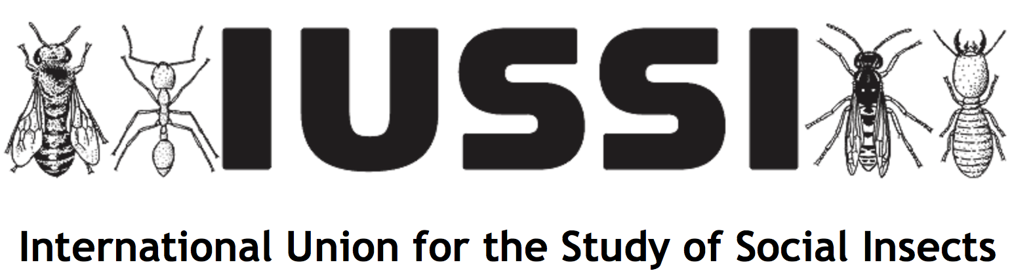

Madeleine Beekman, Secretary-General
Behaviour and Genetics of Social Insects Lab, School of Life and Environmental Sciences,
The University of Sydney, Sydney, 2006 NSW, Australia

We held our quadrennial Congress in Guaruja, Brazil, August 5-10 2018. The quandrennial congress is our main congress and normally attracts around 900 delegates.

We further have a journal, Insectes Sociaux, which publishes 1 volume a year, 4 issues per volume.

Social media handles:
Facebook
https://www.facebook.com/InsectesSociaux?ref=bookmarks
Blog
http://insectessociaux.com/
Twitter
https://twitter.com/inssociaux

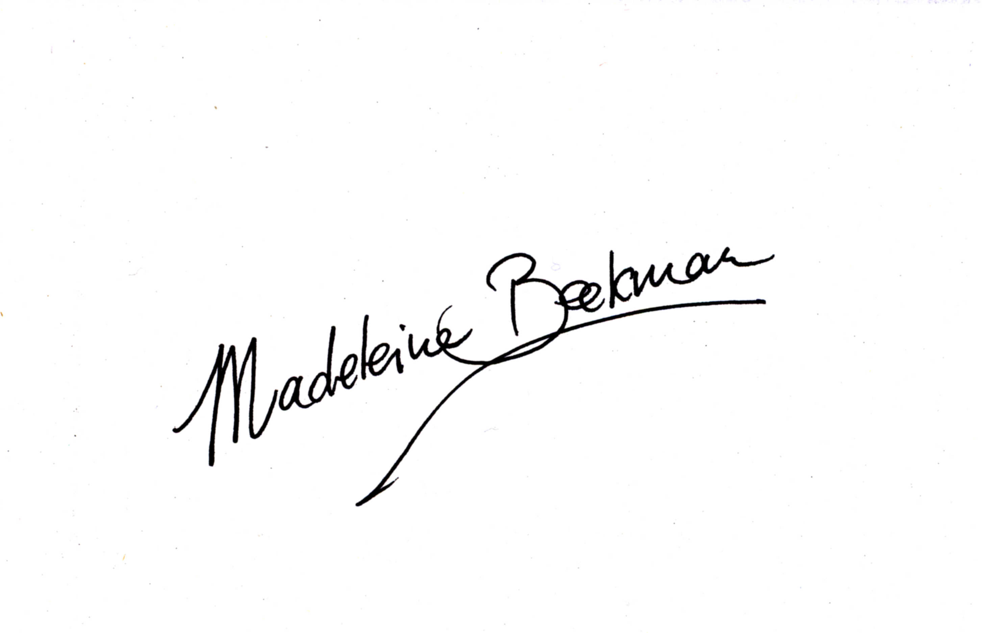
Madeleine Beekman, Secretary-General

